Half-Height Design Doc

# High Concept

Half-Height is a 2D action platformer where the player overcomes powerful foes by slashing, blocking, dashing and jumping.

The player is a knight that wields a sword and shield, fighting their way through a palace with the goal of conquering the villain within.

Half-Height is a challenging experience that will test player skill and mastery of the controls.

# Core Experience

* **Challenge**: The core of Half-Height’s experience centres around challenging the players skill and mastery of the various systems. Enemies are hard to beat with fast attack patterns and aggressive behaviour, emphasising the players feeling of victory and accomplishment.
* **Fantasy**: The world of Half-Height will draw the player in, allowing them to escape and experience a fascinating world with a unique style of presentation.

# Gameplay

There will be two levels in the game: an outdoor area that works as the games tutorial and gives a decent level of challenge, and a boss room where the player fights the boss.

## The Player

Using the directional buttons/control stick, the player may move left and right across each room and may jump using the jump button to clamber over and around obstacles and enemies.

The player’s character is quite defensive in their approach to combat; emphasis is placed on approaching the enemy safely using the shield and jumping.

Combat is fast paced and reactive – the player must anticipate and respond to the enemies attacks quickly and decisively. Each action the player has at their disposal occurs instantly and has a short duration, adding to this sense of speed. In Half-Height, the player has several options to deal with each combat scenario as they see fit:

* **Attack:** Attacks are fast and come out instantly, damaging the enemies in front of the player.
* **Backstep:** The player may dash backwards out of danger. While backstepping the player is invincible but can only dodge backwards, cannot attack and is limited in their ability to position themselves. Expert players can move themselves to dash behind an enemy, but this is quite difficult.
* **Block/Parry:** The player may hold the block button to deflect an incoming attack. If timed poorly this will cancel all damage coming towards the player from the front but will knock the player backwards, putting them out of position. If timed perfectly (the player blocks just as an attack lands) the player will mitigate the damage of the attack, become invincible for a short time and will not be launched backwards. The player cannot move while blocking.
* **Jump:** The player is always able to jump throughout encounters and can jump over enemies and attacks. This, coupled with the parry, will allow players to approach enemies to attack.

These actions will be made in response to the various enemy attacks in the game. The enemies leading up to boss of Half-Height will serve as miniature tutorials to prepare the player for the various attacks they will have to deal with in the final encounter.

All attacks will be parry-able with the right timing. The final boss will have many attacks and movement patterns, including but not limited to:

* **Powerslash combo:** The boss will launch a powerful projectile three times by slashing their sword in the air.
* **Lunge:** The boss launches forwards, damaging the player if they collide.
* **Teleport Strike**: The boss teleports above the player and drops down to the ground, damaging the player on contact.

[TO DO: put storyboards here]

# Art Style (to be discussed)

# Target Platform/Audience

This game will be developed for PC, with the initial build platform being Windows 10. Half-Height will be developed for this platform because it is the platform that the developer has the most experience with, and due to its suitability of gameplay style. While the Switch would be an excellent platform for this game, the scope of the project and limited development time requires that the team be focused on developing for a single platform. Other games that share this playstyle also do quite well on PC, such as Hollow Knight, Blasphemous and Bloodstained: Ritual of the Night.

The game is targeted towards hardcore players that enjoy the significant challenge and fantasy of Hollow Knight in a shorter time-period. The game offers a unique world with great intrigue and challenging gameplay which is perfect for these players.

# Technology

The game will be developed using Unity 2D as it is perfect for this style of game. It is also the engine the developer has the most experience with, ensuring a higher quality product.

# Plan

## Team roles:

Liam: Project Manager, Designer, Programmer

Zeb: Artist

## Communication:

Team members will coordinate over discord. A Git Repo will be made, and assets will be made to share the project.

## Initial sprint goals:

Milestone begin date: 4/12/20

Milestone end date: 11/12/20

Goal:

* Plan out how the player character will be programmed. Use draw.io to design the programming structure.
* Create a character that feels good to play as. By the end of this milestone the player will be able to move and jump.
* Art assets for the player character will be in the game. Animations will be added as each feature is worked on.

To deliver:

1. A fully planned out programming structure for the player, detailing the connections between the movement, jumping, attacking, dashing, blocking.
2. Movement and jumping implemented. Movement feels good: high hang-time, not too floaty.
3. Art assets for player: idle, walking, jump.

Definition of done:

1. Design plan for player programming structure complete and printed out for easy reference.
2. Internal testing report player movement feels good, simple and easy to grasp.
3. Art assets created and implemented.

## Art assets:

## Player:

* Idle
* Walking
* Jump
  + Rising
  + Hover
  + 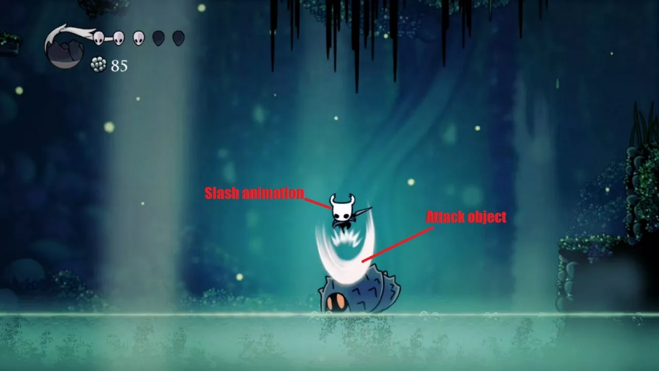Falling
* Back-dash
* Attack
  + Slash animation (quick, speedy)
  + Attack “object”/whoosh (maybe redo to attacking animation to suit? We’ll see though)
* Blocking
  + Parry animation
* Accents:
  + Dash object
  + Jump object

## Boss:

* Idle/Neutral
* Moving/walking
* Power slash
  + Swipe animation
  + Energy swipe
* Lunge
* More?

## Environment:

* Two areas:
  + The game is set in a palace.
  + 2 areas: outside (tutorial area), inside (boss room/throne room)
* Tileset
* Backgrounds – parallax outside
* Boss room – should be fully designed/drawn